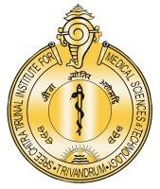

**श्री चित्रा तिरुनाल आयुर्विज्ञान और प्रौद्योगिकी संस्थान, त्रिवेंद्रम, तिरुवनन्तपुरम - 695 011, केरल, भारत**

SREE CHITRA TIRUNAL INSTITUTE FOR MEDICAL SCIENCES AND TECHNOLOGY (SCTIMST)

THIRUVANANTHAPURAM–695011, KERALA, INDIA

(An Institute of National Importance under DST; Government of India) (***एक राष्ट्रीय महत्व का संस्थान, विज्ञान एवं प्रौद्योगिकी विभाग, भारत सरकार)***

[www.sctimst.ac.in](http://www.sctimst.ac.in/)

**Press Release**

**Sree Chitra Tirunal Institute for Medical Sciences and Technology launches its New Drug-Eluting Bone Graft Product**

A product launching function has been organised by SCTIMST in Trivandrum on 24 January 2025, in which two innovative drug-eluting bone graft products were flagged-off for distribution. Hon’ble. President of SCTIMST, Shri. S. Kris Gopalakrishnan, unveiled the products under the brand names CASPROand BONYX***,*** developed by the research team at the Biomedical Technology Wing of SCTIMST and commercialized by M/s. Onyx Medicals Pvt. Ltd., Meerut, UP.

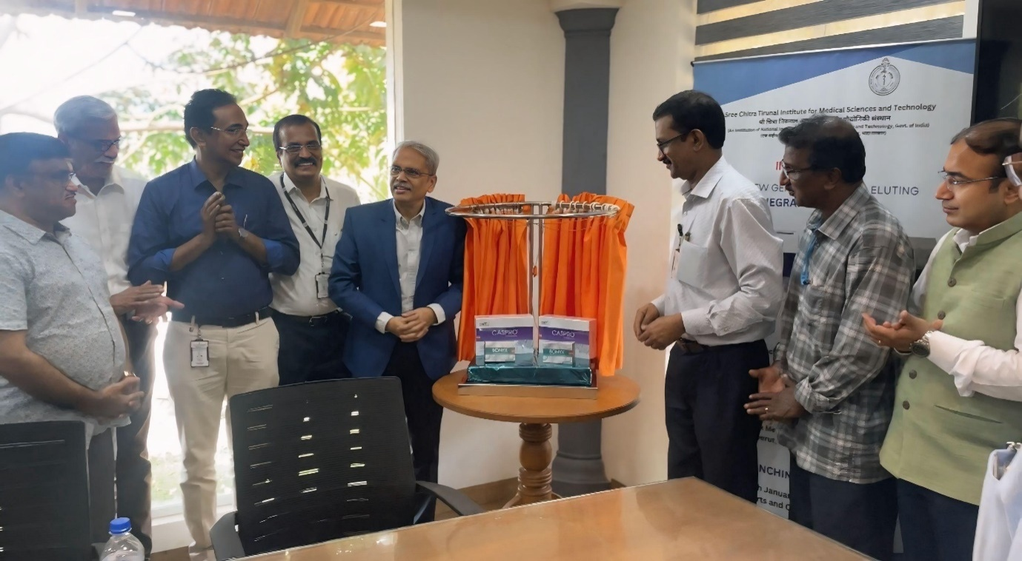

‘BONYX’ contains bioceramic beads for local drug delivery in bone, mainly to handle bone infections. In this product, the bone mineral composition is designed as ceramic beads with multi-modal porosity, through a patented process. The beads allow the vacuum loading of antibiotics or drugs in liquid form, and then release the same in the implanted region in a controlled manner, sustainable for more than 30 days. Being composed of osteoconductive minerals, they integrate with native bone issues ensuring the dead-space management and local bone regeneration. ‘CASPRO’ is a bioactive, mouldable and self-setting bone cement designed for drug delivery in bone. The product is composed of synthetic medical grade basanite (or calcium sulfate hemihydrate mineral), fortified with phosphate ions, prepared through a proprietary ‘drowning out’ precipitation process. On wetting with aqueous solution, the powder forms a putty or paste which could be used for the repair of bone defects. In addition, the cement gives provision to add antibiotics or drugs to it, in either powder or liquid form, and facilitate the controlled release for a period of over 21 days. Both products are the results of years of scientific research and development and validation for regulatory approval as per International Standards.

While unveiling the products, Shri. Kris Gopalakrishnan, mentioned that the launching marks a remarkable milestone in the field of medical technology, reflecting the collaborative efforts of scientists, engineers, and industry professionals. This partnership has demonstrated the potential of Indian scientific excellence, and also highlighted the power of industry-academia collaborations in advancing healthcare solutions. He also congratulated the research team for developing the drug-eluting bone graft products through innovative R&D efforts, and M/s Onyx Medicals, for their unwavering commitment to bringing these unique products to market. Also, he acknowledged the contributions of healthcare professionals, regulatory bodies, and all stakeholders who supported the endeavour of ensuring that the products meet the highest standards of quality and patient safety.

Ensuring unfailing support from Department of Science and Technology, Government of India, Dr. Manoranjan Mohanty, Head of Autonomous Institutes Division in Department of Science and Technology, Government of India, gave felicitations on-line, on behalf of Prof. Abhay Karandikar, Hon’ble Secretary, Department of Science and Technology, Government of India.

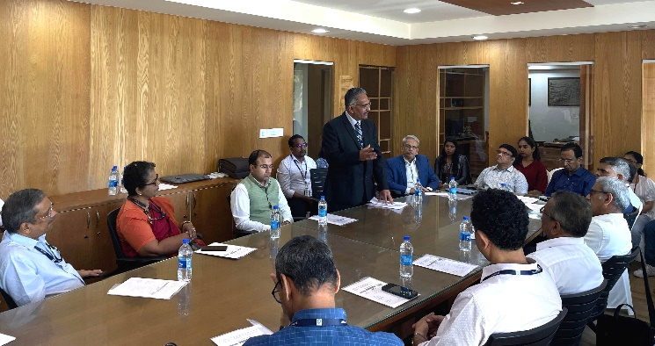 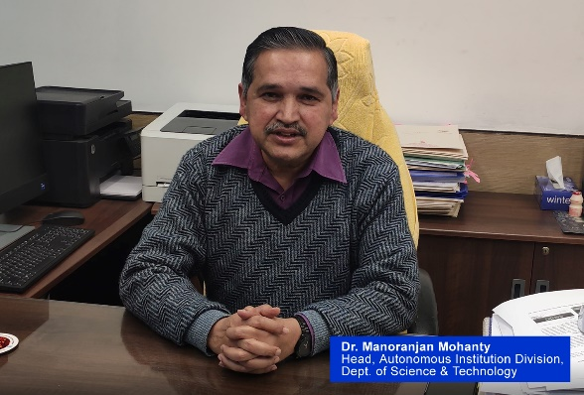

The leader of the research team, Dr. Hari Krishna.Varma, Head, Biomedical Technology Wing, SCTIMST described the path of development of the products. These are off-shoots of the project on “Bioceramic Based Drug Delivery Platforms” supported in the Technical Research Center (TRC) scheme of Department of Science and Technology, Government of India. He acknowledged the roles of the co-investigators of the project, Dr. Manoj Komath and Dr. Francis Fernandez. The technical support for the product development, from process design to pilot production, was provided by Dr. Suresh Babu, Dr. K.V.Nishad, Dr. K.R.Remya and Mr. S.Vijayan. Various labs in the Campus, especially Tissue Culture, Thrombosis, Microbiology, Toxicology and Histopathology contributed to the evaluation of the products. The Technology Business Division managed the timely technology transfer of the products by identifying an appropriate industrial counterpart.

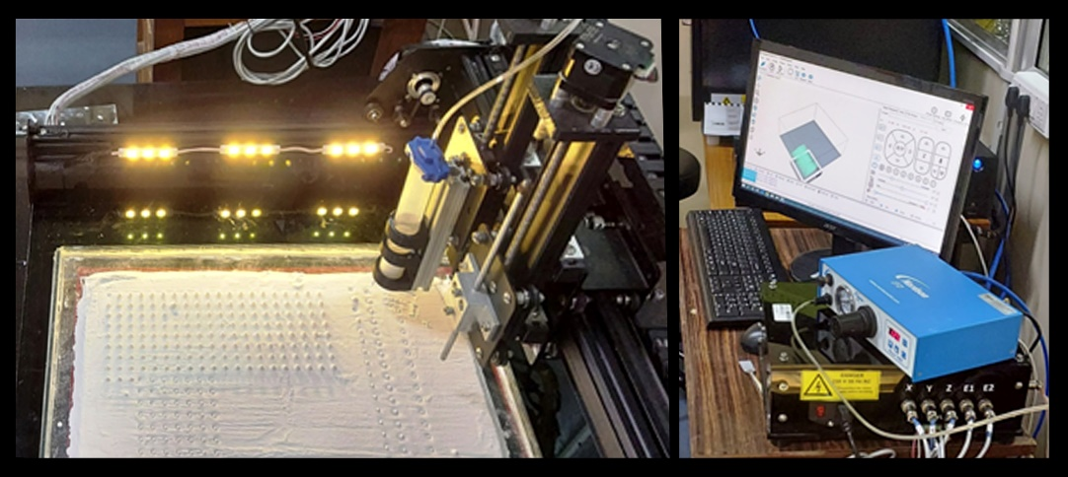

Clinical collaborators shared their experiences with the product development. Dr. K.V.Menon, Senior Consultant in Spine Surgery mentioned his connections with the research team for more than 25 years in conducting clinical studies of the bioceramic products developed in SCTIMST. The collaborative work realised the indigenous development and commercialization of synthetic bone graft materials. Dr. Easwer H.V., Professor, Neurosurgery (SCTIMST), remembered that the project on drug eluting ceramics originated out of the unmet need from Dr. Vrisha Madhuri of CMC Vellore, to deal with the osteomyelitis in children. This is a challenging condition which can lead to eventual limb loss. Later, in pilot studies, the drug-eluting ceramic bead technology proved it highly successful. The clinicians identified that the drug-eluting bone grafts are opening up new possibilities in the management and regeneration of infected or defective bone. The product may be used to provide a scaffolding for bone cells to grow through.

Mr. Proyam Rastogi, Sales Director of M/s Onyx Medicals, gave a description of the efforts made by them to scale-up, manufacture and distribute these products, so that it can reach throughout the Country for the needy. The making of the products CASPROand BONYX, which spanned over a decade, demonstrates a viable model in the Country to develop biomedical products of global relevance through team work and academia-industry collaboration.

