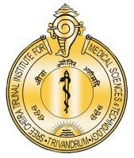

**श्री चित्रा तिरुनाल आयुर्विज्ञान और प्रौद्योगिकी संस्थान, त्रिवेंद्रम, तिरुवनन्तपुरम - 695 011, केरल, भारत**

SREE CHITRA TIRUNAL INSTITUTE FOR MEDICAL SCIENCES AND TECHNOLOGY (SCTIMST)

THIRUVANANTHAPURAM–695011, KERALA, INDIA

(An Institute of National Importance under DST; Government of India) (***एक राष्ट्रीय महत्व का संस्थान, विज्ञान एवं प्रौद्योगिकी विभाग, भारत सरकार)***

[www.sctimst.ac.in](http://www.sctimst.ac.in/)

**Press Release**

**26th Annual National Conference of the Indian Society of Neuroanaesthesiology and Critical Care (ISNACC2025)**

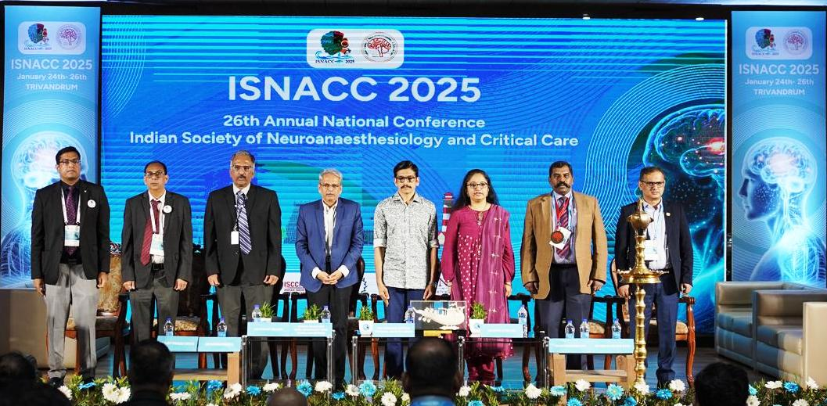

**Thiruvanathapuram, Kerala:** The 26th Annual National Conference of the Indian Society of Neuroanaesthesiology and Critical Care (ISNACC 2025) inaugurated at the Kerala Arts and Crafts Village, Kovalam. The event was hosted by the Department of Neuroanaesthesiology and Critical Care at the renowned Sree Chitra Tirunal Institute for Medical Sciences and Technology (SCTIMST), one of India’s leading medical institutions.

The inaugural function on January 24th was attended by the distinguished gathering, including the Chief Guest, His Highness Avittom Thirunal Aditya Varma, Guests of Honor were Padmabhushan Shri Senapathy Kris Gopalakrishnan and Dr. Divya S. Iyer, IAS and other esteemed dignitaries

The conference, which conducted from January 24-26, promised to be a landmark gathering for experts, researchers, and clinicians specializing in Neuroanaesthesia and Critical care. This specialized field is crucial in managing patients undergoing complex neurosurgical procedures and critically ill neurological patients. The conference featured insightful keynote addresses, engaging panel discussions, interactive workshops, and presentation of the latest research findings. These sessions aimed to foster an exchange of ideas, explore the latest technological innovations in Neuroanaesthesia and Critical care to discuss strategies for improving patient care in this highly specialized domain.

This conference served as a vital platform for networking among leading professionals, shaping the future of neuroanaesthesia, and ensured that the best practices continue to be applied in patient care. With experts from across the globe in attendance, ISNACC 2025 is poised as a significant event in the ongoing development of Neuroanaesthesia and critical care in India and beyond.